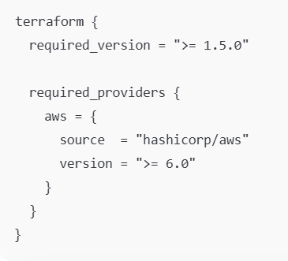
Required Version
Terraform will refuse to run this config if your Terraform CLI is older than 1.5.0.
This protects you from weird errors if the code uses features that don’t exist in older Terraform versions.
Required Providers
declares which provider plugins are needed.
aws = { ... }
This tell it its using the AWS provider, and its calling it aws
source = "hashicorp/aws"
This tells Terraform where to download the provider from (the provider’s address in the Terraform Registry).
Here it’s the official AWS provider maintained under the hashicorp namespace.
version = ">= 6.0"
Terraform will only install/use AWS provider versions 6.0 or newer.
This is important because provider versions can introduce breaking changes; this pins you away from older versions that may behave differently.

